Needfinding - Personas - Notes
A persona is a representation of a type of customer. Personas answer the question, “Who are we designing for?” and they help to align strategy and goals to specific user groups.

So how do you conduct a persona analysis?
You can begin by compiling everything you know about your customers,
and grouping your findings in a spreadsheet. You could use headings relevant to your areas of study, such as industry, device, time, and goals. Or you could create affinity diagrams by organizing your findings on post-it notes. You might start to see patterns—the industries in which customers work, and what devices they use, at what time of day, and where. From here, you can form questions about your customers and work out what they have in common and also how they differ. Then find the people who form these clusters—either in your existing customer database or by recruiting them—and talk to them.
It's a win-win. You get to learn from customers and they get access to the folks who create the software they rely on.
Personas change over time—create them, learn from them, share them, and then don't forget to revisit them and begin the process anew.

Dairy Studies
- Give people a diary that they complete at a specified time or interval
- Structured task
- Can use journals, cameras, voice, video
- Tailor the recording to the context
- Can scale better than direct observation
- Easier tools -> better results
- May require some practice, training, reminding
Experience Sampling
Lead Users - can source of design ideas
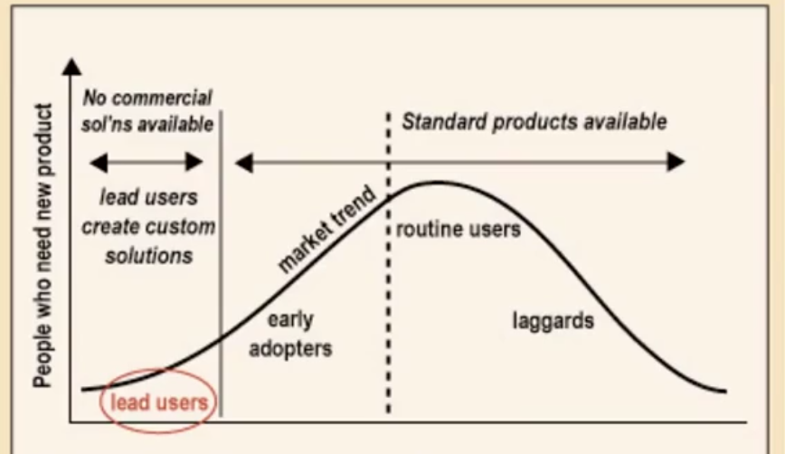
Extreme Users - basically people uses something extremely like reading email every hour
Keeping Users in Mind
Personas - abstract users created by using a model of a person/group
- A model of a person, an example.
- includes demographic information, but should also capture a person's motivation, beliefs, intentions, behavior and goals
- Draw a picture of your persona or use a photo
- give him or her a name, an occupation. a background, a social situation. some hopes, dreams, and goals etc. Give the persona a story to tell
- Knowing what our persona thinks, does, and feel help build empathy
- -so that you can understand the state of mind, emotion, philosophy, beliefs. or point of view of the user
- Empathy leads to insights which leads to design opportunities
Ultimately, it's the design

